

Title I 2025-2026

Parent and Family Engagement Plan

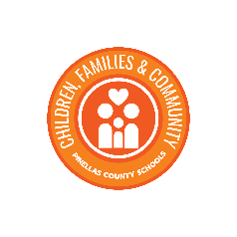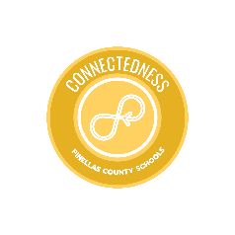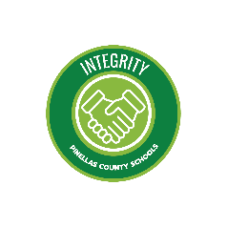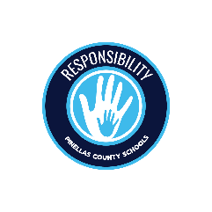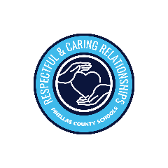

# Table of Contents

Message from the Title l Assistant Director ………………………………………………… 2

Welcome from the Community Outreach Partner ………………………………………. 3

What is Title l? …………………………………………………………………....………………. 4

Title l Goal …….…………………………………………………………………….….…………. 4

A Partnership for Success……………………........................................................... 5

What is Family Engagement? …………………......................................................... 5

Jointly Developed …….…………………………………………………………………………… 6

How PCS Supports Family Engagement ……………………………………………………. 7

Building Capacity ….……………………………………………………………………………. 8

Coordinated Support ………………………….……………………………………………...... 9

Encouraging Family Engagement.………………………………………………………….... 10

Annual Summary ………………………………………………………………………………....11

Acronyms …….……………………………………….…………………………………………. 12

# Message from the Title l Assistant Director

Dear Families and Community Stakeholders,

As the Title I Assistant Director at Pinellas County Schools, I am excited to share our ongoing commitment to fostering an environment where every student thrives and is supported by robust and meaningful family engagement. Our district’s Strategic Priority is to Deepen Authentic Engagement with Families Districtwide. This priority highlights our belief that genuine collaboration with families is crucial for student success.

At the heart of our mission is the commitment to ensure every child has access to a high-quality education, regardless of their background or economic status. Title I, Part A is a cornerstone of our educational efforts, providing critical funding and resources to schools with high numbers or high percentages of children from low-income families. This federal program is designed to help students who are at risk of falling behind academically, offering support that ranges from additional instructional services to essential educational materials.

Our focus is not just on improving academic outcomes, but also on fostering a strong, supportive school community. We believe that collaboration between families, schools, and the broader community is essential for the success of our students. When we work together, we create an environment where every child can thrive.

Here’s how you can be involved and support our efforts:

*Stay Informed*: Keep up with the latest news and updates from your child’s school and the district. Our website and newsletters are excellent resources.

*Participate in School Activities*: Attend parent-teacher conferences, school events, and Title I meetings. Your presence and input are invaluable.

*Encourage Learning at Home*: Activities like cooking together can teach math and science concepts while reading aloud nurtures literacy skills and a passion for books. Engaging in conversations during meals or family outings can enhance vocabulary and critical thinking. Encouraging children to help with household tasks can instill responsibility and practical life skills. By integrating educational moments into everyday routines, families can create a rich learning environment that complements formal education and promotes continuous growth.

*Join Parent and Community Groups*: Engage with Parent Teacher Association/Organizations (PTA/PTO), School Advisory Committee (SAC) meetings, and other community organizations that support our schools. Your voice and participation make a difference.

We are dedicated to providing equitable educational opportunities and closing the achievement gap for all students. Your input and feedback are invaluable to us. We recognize that parents, guardians, and community members play a pivotal role in shaping educational experiences, and we want to hear from you. We will be organizing surveys, and parent advisory committee (PAC) meetings to gather your perspectives and suggestions. Your voice will help guide our efforts to create more effective and inclusive programs that meet the diverse needs of our community.

Together, we can build a stronger, more engaged educational community. You are crucial to this endeavor! Thank you for your continued support and partnership.

Yours in education,

Shannon V. Butler

Dr. Shannon V. Butler

[butlersha@pcsb.org](mailto:butlersha@pcsb.org)

# Welcome from the Community Outreach Partner

Dear Families and Community Stakeholders

As the new **Title I Community Outreach Partner**, I am excited to begin this journey of building strong, supportive relationships with families, schools, and the community. My role is focused on creating meaningful connections that help every student succeed, especially those served under Title I programs.

I understand that families are essential partners in education. My commitment is to:

* **Listen and Learn**: I want to hear your ideas, your concerns, and your hopes for your child’s education. There will be Parent Advisory Committee meetings that will help bring your voice back to the schools and the district.
* **Improve Communication**: I will work with schools about 2-way communications and how important information should be accessible and clear for all families.
* **Encourage Involvement**: Whether through school events, parent meetings, or casual conversations, I want to make it easier for families to be active, engaged participants in school life.
* **Connect Families to Resources**: I will help link families to academic support, community services, and tools to empower student learning at home.

As I grow in this role, I’m here to support, advocate, and collaborate. Together, we can create a welcoming and inclusive environment where every family feels valued, and every child can thrive.

Cassandra Ventura

Cassandra Ventura

[venturac@pcsb.org](mailto:venturac@pcsb.org)

# What is Title l?

Title I is a Schoolwide Federal Program that provides a comprehensive reform strategy designed to upgrade the entire educational program in a school, so every student achieves high levels of academic proficiency. Title I provide extra funding to schools to help all students succeed, especially those who need more support in reading, math and other subjects.



# PCS Title l Goal

If the PCS Title I Department provides differentiated support to Title I schools and families, then a minimum of 10% of our schools will improve at least one letter grade as measured by 2026 FAST data.



# A Partnership for Success

Pinellas County Schools (PCS) is committed to engaging families and the community as equal partners to assist with providing a world-class education with excellence and equity that empowers each student to reach their highest potential. Each year PCS district personnel review their plan for supporting Title I public and private schools and families in building strong partnerships that help students succeed in school. When schools, families, and communities work together to support learning, children tend to do better in school, stay in school longer, and enjoy school more. Title I, Part A provides for substantive family engagement at every level of the program, such as in the development and implementation of the district and school policies, and in carrying out the district and school improvement provisions. Section 1116 of *Every Student Succeeds Act (ESSA)* contains the primary Title I, Part A requirements for schools and school systems to engage parents and family members in their child(ren)’s education.

# What is Family Engagement?

Family Engagement means the participation of parents and family members in regular, two-way, and meaningful communication involving student academic learning and other school activities, including ensuring:

• That families play an integral role in assisting their child(ren)’s learning.

• That families are encouraged to be actively involved in their child(ren)’s education.

• That families are full partners in their child (ren)’s education and are included, as appropriate, in decision-making and on advisory committees to assist in the education.

• The carrying out of other activities, as those described in Section 1116 of Every Student Succeeds Act (ESSA).

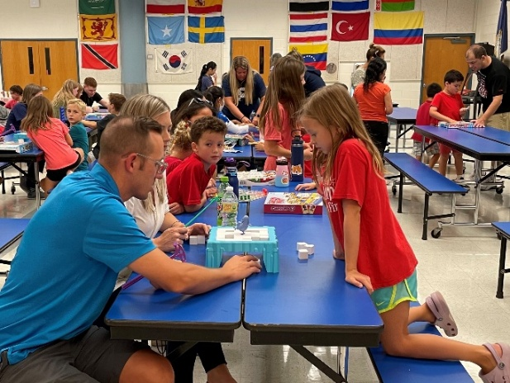

# Jointly Developed

The 2025-2026 District-level Parent and Family Engagement Plan (PFEP) has been jointly developed and agreed upon by stakeholders (i.e. staff, families, community members, etc.) in compliance with Title I federal funding regulations [Section 1112(C) and Section 1116]. The plan describes how the district is conducting outreach to all parents and family members to implement programs, activities, and procedures that promote parent and family engagement. Additionally, the Title I District-level PFEP is made available to the parents and family members of participating children in Title I Schools.

The Pinellas County School District Title I Specialists and Community Outreach Partner team will meet with the Parent Advisory Council (PAC), made up of parent representatives from Title I schools and district personnel two times during each school year, fall and spring. During PAC meetings, data collected from Title l, Part A schools, and the district is discussed, analyzed, processed, and documented. Members have an opportunity to provide their input and will receive resources.

In addition, the Title l department provides technical assistance to schools in writing the school-site PFEP, implementing programs and activities, and understanding the connection between the PFEP and the School Improvement Plan (SIP) to ensure requirements are met. The PFEPs (district and school level) are monitored by the Title l department for implementation using multiple means of data collection including parent meeting minutes, survey instruments, evaluative tools, and digital documentation.

PAC will meet to review and revise the Title I Annual Parent Survey to gather information for the following:

• best day and time of day for parent engagement activities

• areas of need to build parent capacity

• identify barriers that prevent parents from being involved in individual schools and countywide parent activities

• determine if we are meeting the needs of our parents with limited English proficiency and disabled parents.



# How PCS Supports Family Engagement in Title I Schools

PCS will provide coordination, technical assistance, and other support necessary to assist Title I, Part A schools in planning and implementing effective parent and family engagement activities by:

* Providing technical assistance to Title I administrators at staff meetings. Each Title I principal will receive the Title I Handbook with procedures, policies, and specific ESSA requirements. In addition, new Title I principals will receive additional training as well as ongoing support as needed.
* District Title I staff will share information and parent and family engagement best practices with the members of the PAC, who will in turn share information with their various school leadership teams and parent groups.
* The Title I Specialists Team will review and monitor each school’s PFEP, Title I Parent Station, Parents Right to Know, the School-Parent-Student Compact, and information and resources available for families.

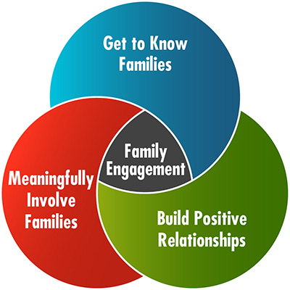

# Building Capacity

***For Families:***PCS will build partnerships between its Title I schools, families, and community with the goal of developing mutual support for student achievement. To develop capacity for this support, we will implement a variety of family and community engagement initiatives.

1. PCS will provide families with information about the overall Title I program and its requirements. Each year schools will convene an annual meeting to describe the school’s participation in the Title I, Part A program and the rights of families to be involved. The district works with its Title I schools to help families understand academic expectations for student learning and progress. Specific information related to curriculum, the State’s challenging academic standards, local and state assessments including alternative assessments, achievement levels, how to monitor progress, and parents' right to know will also be provided. The district and schools also aid parents in understanding the use of its online student information portal and other digital resources including education about the harm of copyright piracy. Notifications about these opportunities will be posted on school and district websites and shared through school messaging systems, newsletters, and social media postings. In addition, the district and school websites contain links to resources, materials, and training to help parents and families work with their child(ren) to improve achievement.
2. PCS will coordinate and integrate the district’s family engagement programs with parent and family engagement strategies, to the extent feasible and appropriate, with other relevant federal, state, and local laws and programs such as the local preschool program and other federal and state-funded preschool programs in the district. Throughout the year, schools will host *Ready, Set… Kindergarten* activities, middle and high school transition nights, school showcase events, and college and career fairs so parents may receive information to help prepare them and their children for the next life stage.
3. To ensure that information related to district, school, parent programs, training, and activities are available to all parents, each Title I school is required to send home and post online information for parents and family members in a clear, family-friendly language and in the home language whenever possible. Information posted on school and district websites will be translated to an extent practicable and upon request. The district will also utilize school phone call systems, district and school websites, local news media, and social media to post information for parents.

***For School Staff:***The district will provide family engagement support. Advising on strategies to improve school-family communication to build ties with the community. Enhancing the value and utility of the contributions of families and how to reach out to, communicate with, and work with families as equal partners.

# Coordinated Support

PCS will coordinate and integrate parent and family engagement strategies from Title I, Part A with other federal programs (including but not limited to Head Start, Parents as Teachers, Voluntary Pre-Kindergarten, Title I, Part D, and Title III, [Sections 1116 (a)(2)(D) and 1116I(4)].

|  |  |
| --- | --- |
| Voluntary PreK-3 and VPK-4: | Title I fund free all-day programs at six school sites, making it possible for more families to enroll and their scholars to benefit from early childhood. |
| Title lll Coordination: | Every fall the Title I Team participates in the ESOL Community Showcase event where resources are provided for families and parent input/feedback is collected. |
| Title l Private Schools Coordinator and Community Outreach Partner: | LEA will support family engagement activities for families of private school Title I participants in compliance with ESEA section 1117(a)(1)(B). The family engagement activities are planned and implemented through the third-party contractor after consultation with private school officials. |
| Title lX Homeless Education: | The partnership supports the funding of homeless education, collaborating to share strategies and best practices about parent and family engagement. The Title l, Part A Homeless Set-Aside will be used to fund the Homeless Education (HEAT) Program staff to assist in the identification, academic support, and regular school attendance and participation of students who meet the federal McKinney-Vento Act (MVA) definition of homeless status. HEAT Program staff provides ongoing homeless education development to school-based staff designed to increase their knowledge of homeless education topics and issues, enhance effective school-to home communication, and increase parental engagement in student's academic progress. |
| Title l Part D Educational Alternative Services: | Neglected and delinquent reservation funds provide supplemental support to students in the areas of educational achievement, dropout prevention, family engagement, and transition services. Title l, Part A will provide salaries that will support Teacher Alternative Education, Paraprofessionals, Technology Related Rentals, and Supplies, which will all help increase student achievement and student and parent engagement. |

# Encouraging Family Engagement

We include our parents in decision-making meetings, workshops, training, and other events. Our Title I schools ensure families feel welcomed, appreciated, and included by:

* providing an inviting school environment
* sending out timely notices of training/meeting dates and times
* offering flexible dates and times and having materials available for parents who did not attend an event
* making accommodations for physical challenges
* providing free childcare at Title I meetings and events
* providing transportation to attend school events
* conducting Title I meetings in nearby community centers and neighborhoods
* providing translation services
* working on jointly developed plans
* building capacity of families
* building capacity of staff

# Annual Survey Report

Annually, a survey will be provided for parents to provide valuable feedback regarding the parent and family engagement activities and programs. The Annual Title I Parent Survey has been embedded into the District's Climate Survey and will be available online at the districts and Title I schools’ websites.

Our schools need your input to support identifying barriers to greater participation by families and using the findings to design strategies to support successful school and family interactions and revise engagement policies.

For more information, please visit our website: [www.pcsb.org/titleone](http://www.pcsb.org/titleone)

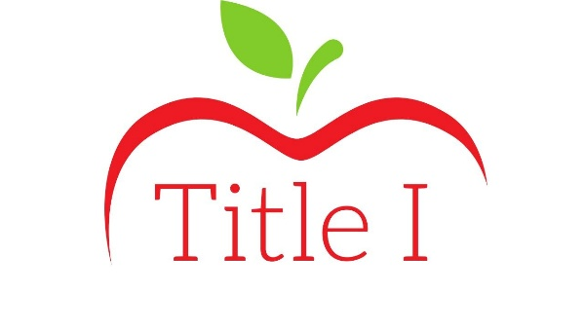

# Acronyms

* PCS – Pinellas County Schools
* ESSA – Every Student Success Act
* PFEP – Parent & Family Engagement Plan
* PAC – Parent Advisory Council
* SIP – School Improvement Plan
* LEA – Learning Educational Agency
* ESEA – Elementary and Secondary Education Act
* ESOL – English for Speakers of Other Languages

